# exception handling in python

# syntax

try:

# code of lines

except:

#show errors

#example

try:

a = int(input("enter a number : "))

i = a + 1

except Exception as e: # if any error stop above execution of lines then it handle by (except exception as e)

print(e)

print(i)

"""

we can customize exception as own statement .

This method is known as [ Raising exception ]

"""

#syntax

try:

#code of line

except:

raise #exception name ("here i stop")

# try with else

#syntax

try:

#code of line

except:

#code of line

else:

print("this lines")

# example

try:

a = int(input("enter a number : "))

i = a - 1

except Exception as e:

print(f" your error {e}")

else:

print("you are done")

'''

else will run after only sucssefully execution of code under the (try)

otherwise it will gives error in (except)

'''

# try with finally

syntax:

try:

#code of line

except:

#code of line

finally:

print("this lines")

#example

try:

a = int(input("enter a number : "))

i = a *2

except Exception as e:

print(f"your error {e}")

exit()

finally:

print("you are done....")

'''

finally will run after execution of code under the (try) or

it will run after giving errors in (except) or

either code is quit(exit) then also it will run

'''

# if __name__ ==" __main__" in python

# it is just a entry point of an code

syntax:

if __name__ =="__main__":

#code of lines

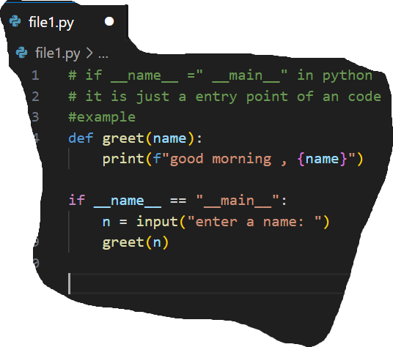#example

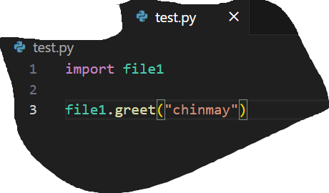

# Global keyword

'''

it is use to change or modified GLobale variable.using

[ Global] as a keyword

'''

#example

a = 20

def func1():

global a

print(f"statement 1: {a}")

a = 13

print(f"statement 2: {a}")

func1()

print(f"statement 3: {a}")

#enumerate function

'''

its is function adds counter ti an itreable values and return its with index

'''

#example

list_1 = ["parth" ,2618,9.1,True]

for index, item in enumerate(list_1):

print(f"{index}] {item}")

# list comprihension

'''

it is a way to create a new list from existing list

'''

#example

list1 = [21,23,14,22,33,44,21,21,12,44,4,21]

list2 = [i for i in list1 if i%2==0]

print(list2)

#lambda function

'''

its is a function which use to avoid code of line

concept of passing function as an argument

'''

syntax:

function_name = lambda argument: expresion

print(function_name(argument))

#example

a = 5

division = lambda a: a+10

print(division(a))

#join or bin method

'''

It is use to add creat a string frome iterable objects

'''

Syntax:

l = []

var_name = "conetent_add".join(l)

#example

l = ["parth","chinmay","yogesh","nayan","nilam"]

sentence = " and ".join(l)

print(sentence,"are friends")

#example 2

l = ["parth","chinmay","yogesh","nayan","nilam"]

sentence = " \n ".join(l)

print(sentence)

#formate method

'''

this is method to formate a string

as early python python use use formate method,

becuse ( f string method is not implemint]

its is similer to f string method

'''

syntax:

Syntax

var_name = "{}".fomate()

var-name = "normale string content {}<- pasiing other variable value".format(var)

example:

a = "parth"

b = 2618

c = "MY name is {} and roll number is {} ".format(a , b)

print(c)

#map function

'''

This function is use to applied function to the provided list

'''

#syntax

map(function_name , list_name)

#example

def even(num):

if num % 2==0:

print(num)

l1 = [1,2,3,4,5,6,7,8,9,10]

list(map(even,l1))

#filter function

'''

This function is use to filter or create a new filtres list frome existing list

when a function applid on given list is return true

'''

#syntax

#filter(function_name , list_name)

#example

def even(num):

if num % 2==0:

print(num)

l1 = [1,2,3,4,5,6,7,8,9,10]

list(filter(even,l1))

#reduce function

'''

its is a function to reduce thing by aplling provided function

end result is sequential

'''

syntax:

reduce(function_name, list_name)

example:

from functools import reduce

l = lambda a , b: a*b

l1=[1,2,3,4,5]

val = reduce(l, l1)

print(val)